We are absolutely thrilled you are interested to join us at Rohlik Group. By now we have spoken to you about your experience and personality in great detail. Next step is to find out how you tackle a task in reality.

**BI Analyst**

**Task 1**

* Discuss metrics in the table below - what is the relationship between those metrics
* Describe what is the table telling us about development in one of the business  
  regions
* Suggest suitable data model for these data - standard retail transactional data table

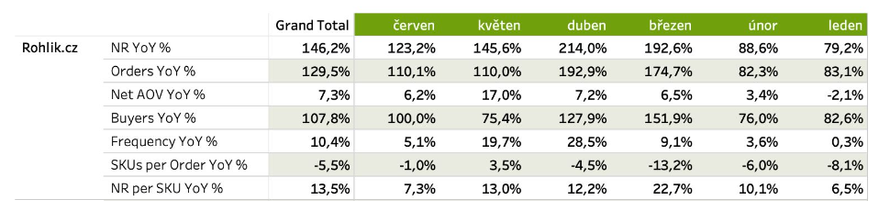

**Task 2**

* What is your impression about the data below - what kind of data is this?
* What is your experience with this kind of analytics?
* Can you describe the problems and advantages of static and dynamic reference data

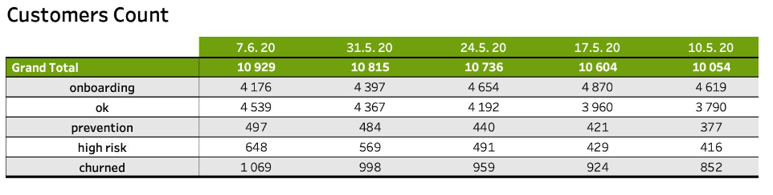

**Format**

We are not strictly set on the form of the presentation. Whatever works for you and you are comfortable with, works for us. So if you just want to have an open forum discussion without any materials, we are in. If you want to present any documents to us, we will provide the tools for it or bring your own. Just let us know.